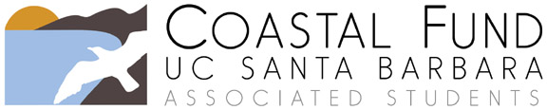

Budget Reallocation Request

Please submit completed form to coastalfund@gmail.com. If you would also like to request an extension of your project’s end date, you must submit a separate Extension Request. You may contact the Coastal Fund Administrative Assistant or Advisor with any questions by emailing coastalfund@gmail.com or by calling (805) 893 – 5166.

The Board will review your request at its next regular meeting and will notify you of its decision as soon as possible. Requests are not approved until voted on by the Board and budget reallocations will not be granted retroactively.

Project Title:
Today’s Date:
Project Number (example, Fall15-01):
Sponsoring Organization:
Primary Contact Name:

Email:
Organization’s Billing/Financial Contact Name:
Email:
Approved project end date:

Please briefly describe your project’s progress to date.

What obstacles have you encountered thus far?

Explain why you are requesting a reallocation of your project’s funds.

Please list the original line items that Coastal Fund approved as listed in your grant agreement and how you are requesting that budget be reallocated. Double check that the approved and requested allocation columns each total your previously approved funding. An example has been provided.

EXAMPLE:

Item Description | Approved  Allocation | Requested  Allocation
2 interns @ $15/hr for 100 hours + fringe benefits | $3093.00 | $3093.00
Mileage for traveling to and from study site | $400.00 | $200.00
Lab materials for chemical analysis | $100.00 | $200.00
Field work protective gear – gloves, waders | $0.00 | $100.00
Total | $3593.00 | $3593.00

Item Description | Approved  Allocation | Requested  Allocation
 | $ | $
 | $ | $
 | $ | $
 | $ | $
 | $ | $
 | $ | $
 | $ | $
 | $ | $
 | $ | $
 | $ | $
 | $ | $
 | $ | $
 | $ | $
 | $ | $
Total | $ | $

Please provide any additional clarification of your changes, if needed.

