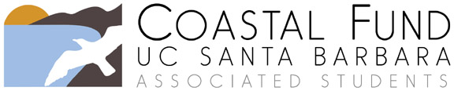

Extension Request

Please submit completed form to coastalfund@as.ucsb.edu. If you would also like to request a reallocation of your project’s funds, you must submit a separate Budget Reallocation Request. You may contact the Coastal Fund Administrative Coordinator or Advisor with any questions by emailing coastalfund@as.ucsb.edu or by calling (805) 893 – 5166.

The Board will review your request at its next regular meeting and will notify you of its decision as soon as possible. Requests are not approved until voted on by the Board.

Project Title:
Today’s Date:
Project Number (example, Fall 15-01):
Sponsoring Organization:
Primary Contact Name:

Email:
Approved project end date:
Requested project end date:

Please briefly describe your project’s progress to date.

What obstacles have you encountered thus far?

Explain why you are requesting an extension and any changes to your project objectives.

Please provide a revised timeline for your project.

Time Period | Actions / Goals

