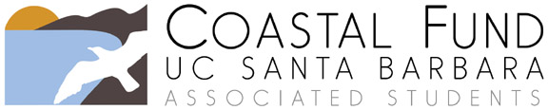

Progress Report

Please submit your completed progress report to coastalfund@as.ucsb.edu. If you would also like to request a budget reallocation and/or an extension of your project’s end date, you must submit a separate Budget Reallocation Form and/or Extension Request. You may contact the Coastal Fund Administrative Coordinator or Advisor with questions by emailing coastalfund@as.ucsb.edu or by calling (805) 893 – 5166.

Project Title:
Today’s Date:
Project Number (example, Fall15-01):
Sponsoring Organization:
Primary Contact Name:

Email:
Approved project end date:

Please briefly describe your project’s progress to date.

Is your project on schedule according to your original timeline? Explain.

If Coastal Fund provided funding for interns, have they been hired? Have they started working? How are they progressing?

What obstacles have you encountered thus far? Do you anticipate any future difficulties?

Would it be possible for Coastal Fund board member(s) to visit your project site? Note that this may not apply to all projects.

Do you have any additional comments?

